BloomNext: Early-Prediction of Harmful Algal Blooms
CS 4262 - Foundations of Machine Learning, Vanderbilt University
Connor Brugger, Trevor Xing-Xie, Nirmay Bhanderi
Introduction
Harmful algal blooms (HABs) can affect wildlife diversity, harm fisheries, and impact public health. Along the Florida Gulf Coast, blooms of the organism Karenia brevis (commonly called red tide) are a recurring threat. When K. brevis concentrations exceed roughly 100,000 cells per liter, they can cause mass removal of aquatic wildlife, beach closures, and respiratory dangers in humans. Being able to predict whether a bloom will occur in the near future would give environmental managers valuable lead time to issue warnings and allocate monitoring resources.
NOAA maintains the Harmful Algal Blooms Observing System (HABSOS), a database of field-collected cell counts tied to specific locations and dates along the Gulf Coast. Adjacent efforts include the NASA Harmful Algal Bloom Detection Challenge, which focused on detecting inland cyanobacteria using satellite imagery, and various studies applying machine learning to ocean color data for bloom nowcasting (Blumenfeld, 2024).
In this project, we use HABSOS field observations to build a binary classification model that predicts whether a bloom will occur in a given coastal area in the next weekly observation. We compare several standard machine learning approaches covered in class (logistic regression, decision trees, SVMs with both linear and RBF kernels, gradient boosting) alongside a random forest and a neural network (MLP). We include a random guessing baseline to confirm that trained models learn meaningful patterns. We evaluate primarily using PR-AUC, which is well suited for imbalanced datasets where the positive class is rare.
Methods
Dataset and Preprocessing
We downloaded the full HABSOS dataset from NCEI, containing 211,834 observations across multiple Gulf states. After filtering for Florida and K. brevis and removing invalid entries, we retained 205,168 observations spanning 1953 to 2024. We binned observations into coastal grid cells at 0.25-degree resolution (roughly 25 km) and aggregated to weekly time steps, producing 53,998 cell-week records across 498 unique grid cells.
We defined a binary one-step-ahead target label called BloomNext: for a given grid cell and week, BloomNext = 1 if the maximum K. brevis cell count in that cell exceeds 100,000 cells/L in the next weekly observation, and 0 otherwise. The positive class rate is 7.3%, confirming significant class imbalance. Figure 1 shows the bloom rate over time, the cell count distribution, and the class balance.
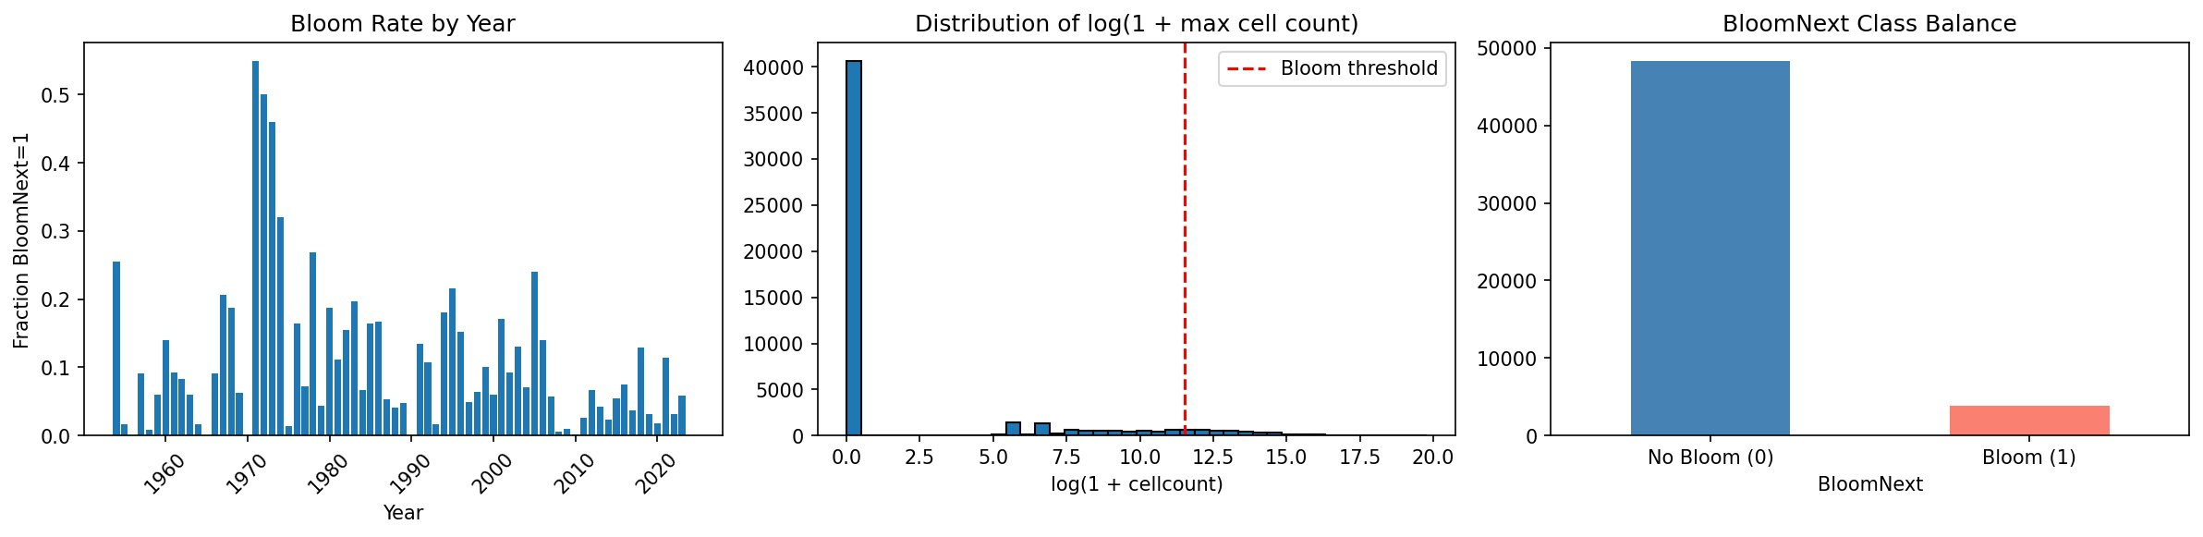
Figure 1: (Left) Annual bloom rate showing temporal variation. (Center) Distribution of log cell counts with bloom threshold. (Right) BloomNext class balance.
Feature Engineering
We engineered 13 features from the HABSOS field data: current-week max and mean log(1 + cell count), a binary bloom indicator for the current week, previous-week max log count and bloom indicator, rolling 4-week max log count, mean log count, and bloom week count, week-over-week change in max log count, field-measured water temperature (median-imputed at 25.4 C for missing values), cyclical month encoding (sin and cos components to capture seasonality), and a spatial neighbor bloom count (number of adjacent grid cells currently experiencing a bloom). After requiring 4 weeks of lookback history, the final dataset contains 52,090 samples.
We used mutual information scoring (SelectKBest) to rank features by their individual predictive value for the target variable. We also produced PCA and UMAP projections (Figure 2) to visualize whether bloom and no-bloom samples separate in reduced feature space. The PCA plot shows that bloom samples (red) tend to cluster along the positive PC1 direction, consistent with the dominance of cell count features.
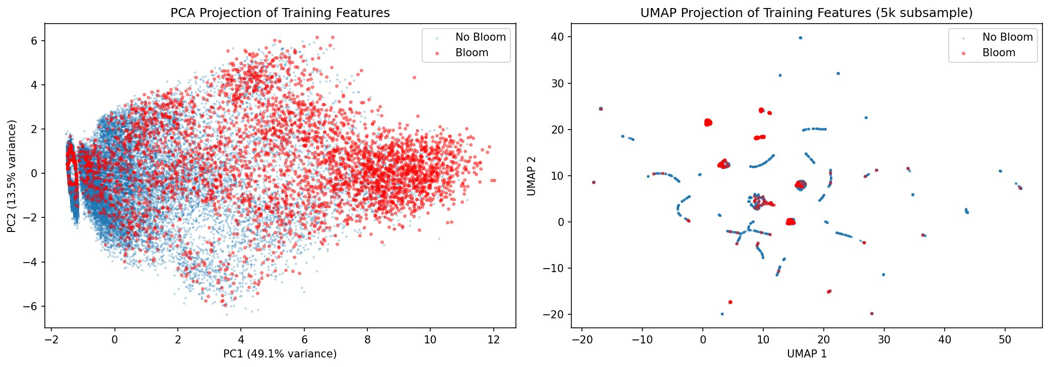
Figure 2: PCA (left) and UMAP (right) projections of training features colored by BloomNext class. Bloom samples cluster along the positive PC1 axis.
Models
We compared seven trained models against a random stratified baseline. Logistic Regression, SVMs, Decision Tree, and Random Forest used class_weight='balanced' to handle the class imbalance by weighting bloom samples higher during training. For SVMs, we tested both a linear kernel and a Gaussian RBF kernel; the RBF kernel uses the kernel trick to implicitly map features into a higher-dimensional space. We also trained a neural network (MLPClassifier with early stopping). Gradient Boosting and the Neural Network operate on the raw class distribution.
Hyperparameter Tuning and Evaluation
We used 5-fold stratified cross-validation with GridSearchCV to tune hyperparameters: C for Logistic Regression and SVMs, n_estimators/max_depth/learning_rate for Gradient Boosting and Random Forest, and hidden layer architecture/alpha for the Neural Network. We used a time-based train/test split (training on 1954-2022, testing on 2023-2024) and evaluated using PR-AUC (primary), F1, MAE, and RMSE. SVMs were trained on a 30,000-sample subsample due to their quadratic time complexity.
Results
Table 1 shows test set performance for all models. All seven trained models substantially outperform the random baseline (PR-AUC = 0.051), confirming that the engineered features carry meaningful predictive signal.
Model | CV PR-AUC | Test PR-AUC | F1 | Prec. | Recall
Random Baseline | 0.074 | 0.051 | 0.054 | 0.044 | 0.069
Logistic Regression | 0.531 | 0.462 | 0.457 | 0.311 | 0.862
Decision Tree | 0.506 | 0.492 | 0.427 | 0.279 | 0.908
SVM (Linear) | 0.554 | 0.449 | 0.409 | 0.268 | 0.862
SVM (RBF) | 0.434 | 0.418 | 0.423 | 0.275 | 0.908
Random Forest | 0.562 | 0.485 | 0.425 | 0.280 | 0.885
Gradient Boosting | 0.565 | 0.491 | 0.486 | 0.614 | 0.402
Neural Network | 0.562 | 0.465 | 0.358 | 0.611 | 0.253
Table 1: Test set results for all models, sorted by type. CV PR-AUC is from 5-fold cross-validation on the training set.
Decision Tree and Gradient Boosting achieved the highest test PR-AUC (0.492 and 0.491 respectively). Gradient Boosting had the best F1 score (0.486) and the highest precision (0.614), but at the cost of lower recall (0.402). The simpler models (Logistic Regression, Decision Tree, SVM, Random Forest) achieved much higher recall (above 0.86) but with lower precision. The Neural Network underperformed the tree-based models, consistent with the well-known finding that gradient boosting tends to outperform neural networks on structured tabular data with a modest feature set. Figure 3 shows the precision-recall curves and Figure 4 shows model comparison.
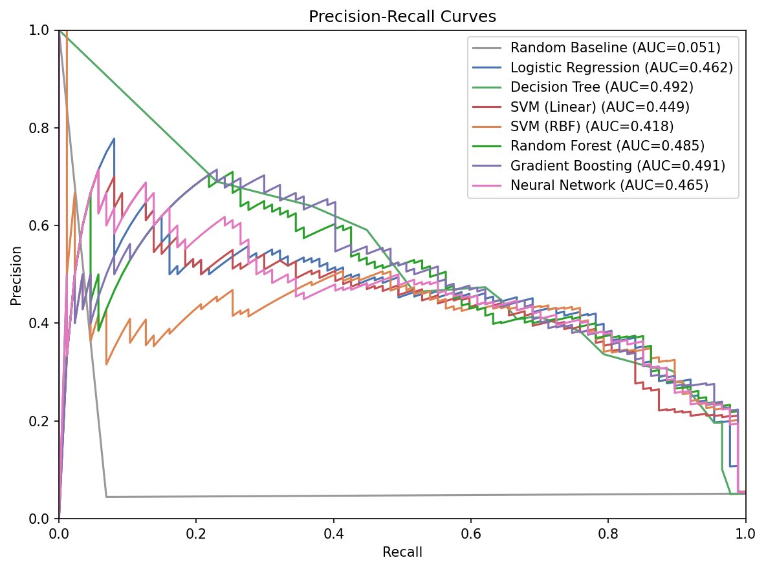
Figure 3: Precision-recall curves for all models. The random baseline (gray) hugs the bottom at ~0.05, confirming all trained models learn meaningful patterns.
Feature importance analysis shows that current-week max log cell count dominates Gradient Boosting (roughly 70% of total importance), while neighbor bloom count and month seasonality are the second and third most important features. In Logistic Regression, the 4-week rolling max, neighbor blooms, and month (sin component) carry the largest absolute coefficients, suggesting these features capture complementary temporal and spatial information about bloom risk.
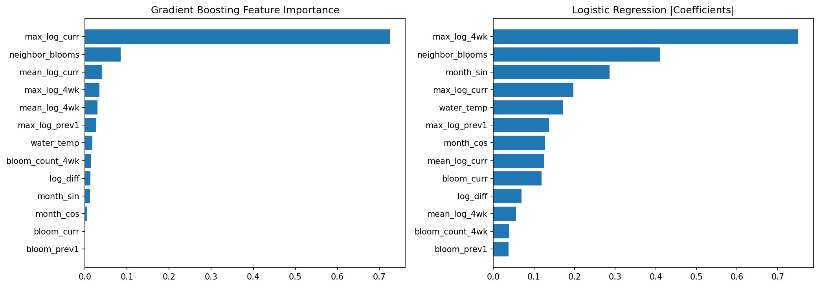
Figure 4: Feature importance (Gradient Boosting, left) and absolute coefficient magnitudes (Logistic Regression, right).
Discussion and Conclusions
All trained models substantially outperformed random guessing (PR-AUC ~0.05), confirming that the engineered features capture real predictive signal about upcoming bloom events. The best models achieved PR-AUC near 0.49, representing roughly a 10x improvement over the baseline. The strongest single predictor is the current-week maximum log cell count, which makes intuitive sense: blooms tend to persist and grow over consecutive weeks.
The spatial neighbor bloom count and seasonal features (month sin/cos) were among the most important features for both tree-based and linear models, validating the decision to add them. This suggests blooms have both temporal persistence and spatial spread dynamics that the models can exploit.
The Neural Network (MLP) underperformed tree-based ensemble methods, achieving the lowest recall (0.253) of any trained model. This is consistent with the broader ML literature showing that gradient boosting outperforms neural networks on tabular data with moderate feature counts. The MLP also lacks native class weighting support, which disadvantaged it on this imbalanced problem.
A key limitation is that we used only HABSOS field observations and did not incorporate satellite-derived features such as sea surface temperature or chlorophyll-a from NASA MODIS. The dataset also has sparse and irregular temporal sampling, meaning that the "previous week" feature sometimes spans much longer gaps. Future work could integrate satellite data for consistent spatial coverage, add more lag features, and explore ensemble stacking of the top models.
Contributions
Trevor Xing-Xie: Data acquisition and initial inspection of the HABSOS dataset. Nirmay Bhanderi: Feature engineering, exploratory analysis, PCA/UMAP visualization. Connor Brugger: Model training pipeline, hyperparameter tuning, evaluation framework, and report writing.
Resources
We used Claude (Anthropic) to assist with code generation for the data processing pipeline, model training loop, and report formatting. All generated code was reviewed, tested, and adapted by team members. We used scikit-learn for all model implementations and evaluation metrics, and UMAP (umap-learn) for dimensionality reduction visualization.
References
Blumenfeld, Josh. "Applying Machine Learning to Harmful Algal Blooms." NASA Earthdata, 13 Feb. 2024.
"Harmful Algal BloomS Observing System (HABSOS)." National Centers for Environmental Information (NCEI), 15 Oct. 2020.
Ng, Andrew. "CS229 Lecture Notes: Support Vector Machines." Stanford University.
Ng, Andrew. "CS229 Lecture Notes: Regularization and Model Selection." Stanford University.

